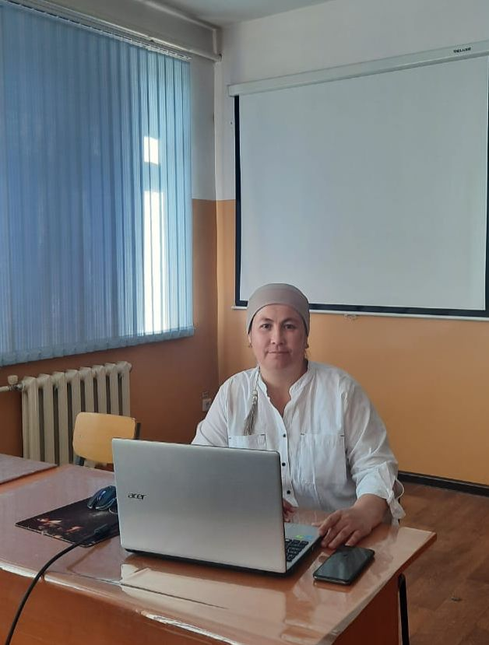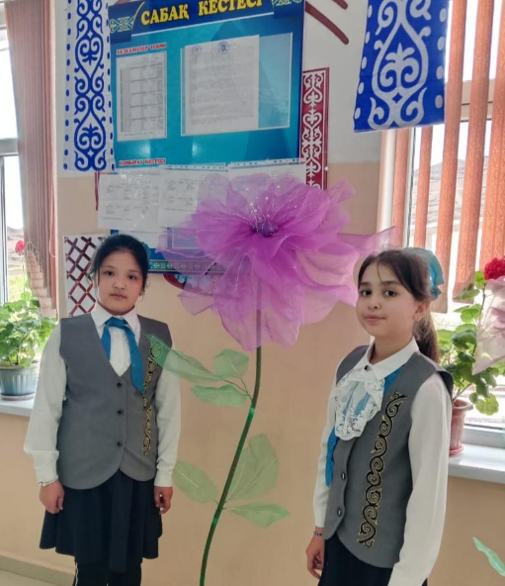

**РАХМАНКУЛОВА Эъзоза Хусниджановна,**

**№76 жалпы білім беретін мектебінің 4 «Ә» сынып оқушысы.**

**Жетекшісі: НИЯЗМЕТОВА Умида Абдимажитовна,**

**Ағылшын тілі мұғалімі.**

**Түркістан облысы, Сайрам ауданы**

**THE BENEFITS OF LANGUAGE LEARNING**

"A person who knows two languages ​​is better than a person who knows one language... Everyone should learn three languages ​​if they have money and a situation; mother tongue, the language of the state where he lives and the language that all people try to learn" (Proverbs of Ismail Gasprinsky. "A Legend", 2014, No. 20).

In the process of learning a foreign language, a person learns the language of another nation, the ways of forming sentences, enters into its thinking system and steps into its spiritual world; reveals the national identity of a new people. By speaking in a foreign language, he thinks nationally; this will bring closer to that nation. Most importantly, knowledge of other languages ​​brings people closer to each other, nation to nation, nation to nation.

In the course of learning a language, a person's ability to communicate, socialize, and increase his knowledge increases up to two or three times. Because each language is a whole world in itself. By learning a language, a person opens the door to a new world, another building of world civilization, enters it and begins to get acquainted. First of all, the informational, cultural and economic space of a person will expand and his knowledge will increase. I am also studying today as a gift of independence. My goal is to live up to the hopes of the country and the trust of my parents and become an English teacher like my English teacher Aunt Umida. I promise to work tirelessly to achieve this goal.